xpedx.com Next Generation
Technical Design Specification – <Moving Order Marked Complete >

Author: | Hemachandra,G
Version: | 0.1
Date Created: | 02/06/2010
Last Updated:

Document Revision History
Revision | Date | Description | Author
0.1 | 02/06//2010 | Draft | Hemachandra.G

Document Approval History
Name | Signature | Date | Version Approved/Comments

Reference Documents
Document Name | Description | Owner | Location

Table of Contents
1. Introduction 3
1.1. Purpose 3
1.2 Nomenclature 3
1.3 Performance Considerations 3
2. Technical Components 3
2.2 Components Overview 3
2.3 Component Design 3
2.3.1 Design for xpedxAsynchLoadItemMaster Error! Bookmark not defined.
2.3.2 UI Design 3
2.3.3 UI Validations 3
2.3.4 Input Document 3
2.3.5 Output Document 3
2.3.6 Configuration 3
2.3.1.1. <Insert Sub-Component Name> 3
3. Database Extensions 3
4. Exception and Error Handling 3
5. Security Aspects 3
5.1 Ownership 3
5.2 Encryption 3
5.3 Audit Trail 3
5.4 Other Security Aspects 3
6. Dependencies 3
7. Unit Test Cases 3
7.1 <Insert Component Name> 3

1. Introduction

Purpose
This document is the design document for the Moving Order from Creation to Marked Complete Status. The document mentions the steps for Moving Order from Created Status to Marked Complete Status.

1.2 Nomenclature
<Glossary of terms - list only new terms applicable to this design>

Term | Description

1.3 Performance Considerations

Technical Components

2.1 Components Overview
Moving Order Marked Complete Status Component moves the Created Order from Created to Marked Complete Status.

2.2 Component Design

- XPXMarkedOrderStatusAPI

Step 1: Get the OrderheaderKey from the parameter and create the xml
Order document.

Step 2: Invoke the getOrderDetails API .

Step 2.1 :Get related Elements such as OrderNo,EnterpriseCode,Buyer
Organization Code,Seller Organization Code, from the Xml In the Method
getAllOrderDetails.

Step 3: Create an Xml Shipment along with related attributes.

Step 4: Invoke the confirmShipment API with xml from 3.

Step 5:Create the Xml for OrderStatusChange .

Step 6:Invoke the changeOrderStatus API from 5.

2.3.2 UI Design
<This section is applicable to UI components. Provide a UI mockup and elaborate the design for UI>N/A

2.3.3 UI Validations
<This section is applicable to UI components. Provide the various validations that need to be applied for each field/control on the UI mock-up>N/A

2.3.4 Input Document

Passing the Order HeaderKey

The sample input xml for XPXMarkedOrderStatus is:

<Order OrderHeaderKey=”20100520150244219231” />

2.3.5 Output Document
<Provide a sample output XML with valid values for each attribute>N/A

2.3.6 Configuration

- XPXMarkOrderToCompleteService

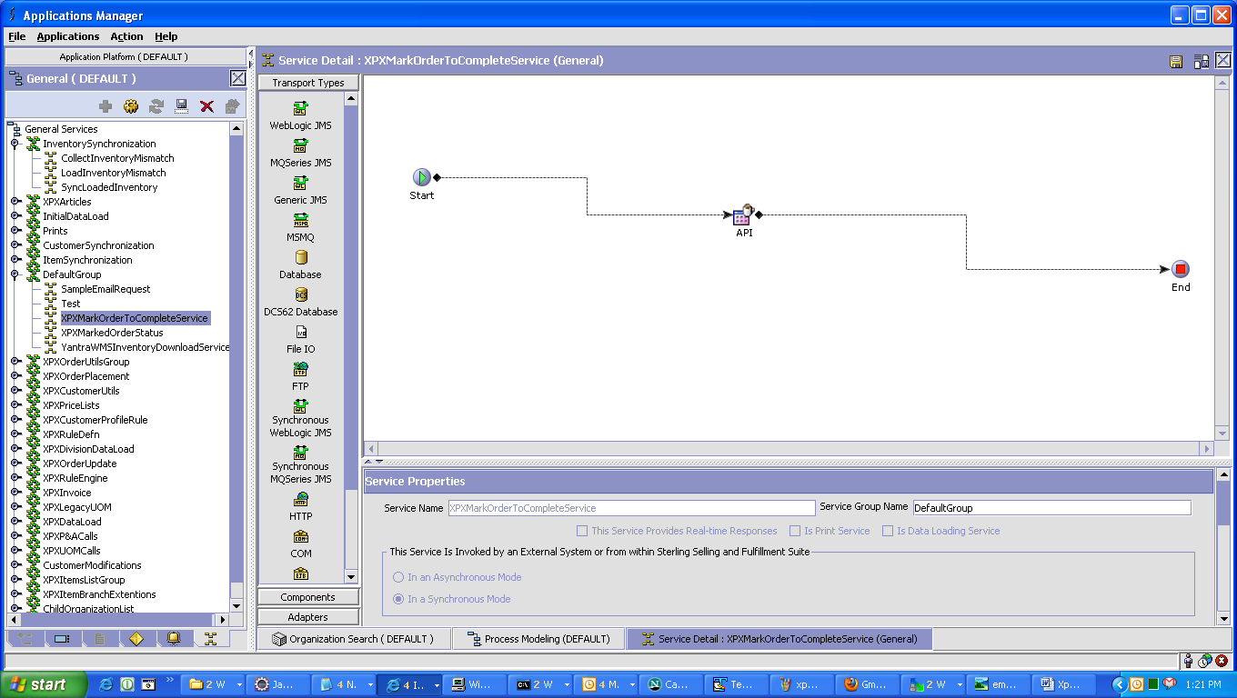

2.3.1.1. <Insert Sub-Component Name>
<Elaborate input and output of each sub-component if applicable>N/A

- Input Document

- Output Document

3. Database Extensions
<Provide the database extensions required for the component in the format provided below. The data types need to be clearly specified. Always Out-of-the-box data types should be reused. If a data type for the given combination doesn’t exist, a new data type name should be specified>

4. Exception and Error Handling

5. Security Aspects
<Provide details on the security aspects of this implementation. Where would these security components reside, what will be encryption that will be used and any audit trails required>N/A

5.1 Ownership
5.2 Encryption
5.3 Audit Trail
5.4 Other Security Aspects

6. Dependencies & Assumptions
<For issues that are dependent on customer: Record all dependencies made for this design including business requirement, performance and technical factors, etc. in JIRA and list the JIRA tickets numbers here

JIRA no | desc | To be validated by  (Team/Person) | Status | Implications if incorrect

<For issues those aren’t dependent on customer: Record all dependencies made for this design including business requirement,performance and technical factors, etc. here

Include only those that are not already documented in SDD If there are changes in SDD, reference the specific dependency and state the revised assumption. New assumption should be approved prior to design review> XReference Section 2.8 – Assumptions in Functional Design Document.

No. | Assumption | To be validated by  (Team/Person) | Status | Implications if incorrect
 | OrderHeaderKey would be retrieved through xml in parameter
2 | All the required elements and attributes of Order would be available.

7. Unit Test Cases
<Elaborate unit test cases for all the components. Every unit test case should include description, pre-requisites, expected results, etc. The below section should repeat for each component>

7.1 <Insert Component Name>

Test No. | Test Description | Execution Instructions | Expected Result

